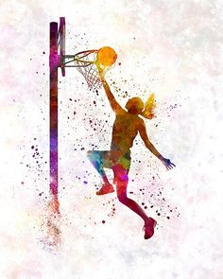

**Dave Felici** [**dfelici@bgcomaha.org**](mailto:dfelici@bgcomaha.org) **402-871-3715**

**Bellevueyouthbasketbal.com**

**Register on Tourney Machine Click Below**

**https://tourneymachine.com/Public/Results/Tournament.aspx?IDTournament=h20210715212736983477639d4428d4d**

$150 per Team – 3 Game Guarantee – Certified Officials – 20 min halves – Full Concession Stand – Flexible Scheduling – **(Multi – Divisions (Platinum – Gold – Silver – Bronze – Recreation)** – 1st place medals per pool – Quality and Beautiful Facilities

**Last Year we had over 350 Teams from around the Midwest!**

**Details**

***The Throw Down in B Town***

***Basketball Classic***

***March 4-6, 2022***